create a static website for women accessories

e-commerce website called "BATEL COLLECTION"

this website must have nav bar of(home,shop,clothes.shoes,perfurme) and the right color conor there must be a logo for the company

2.below the nav bar there must be a an adversing board like this one that
slides showing the 2026 new product
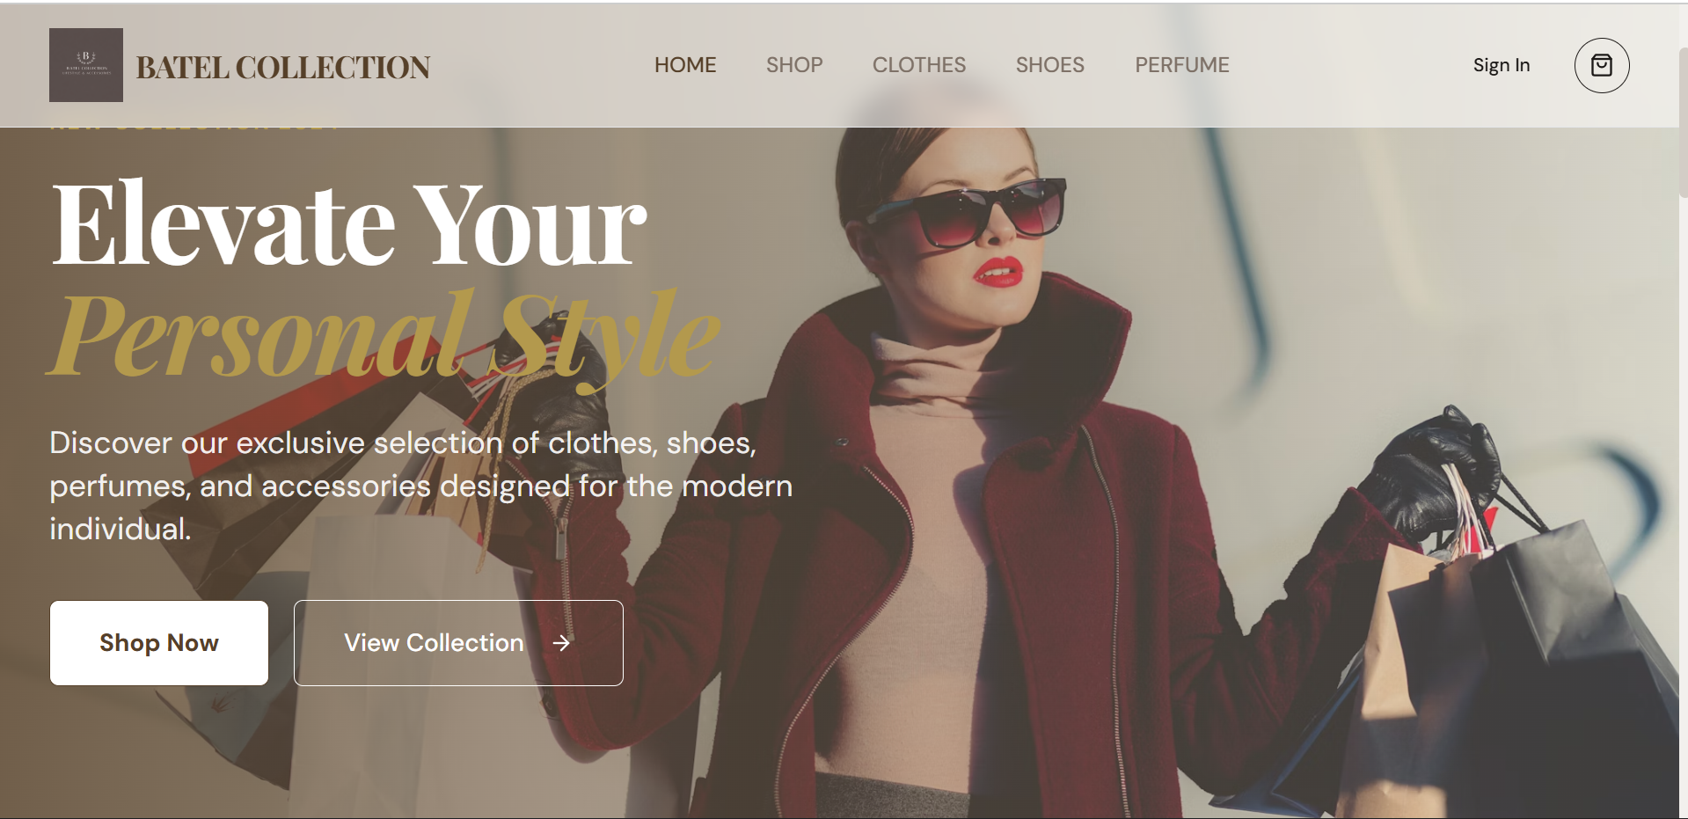
3.and below the this board there must be list of item but grouped which look like this one
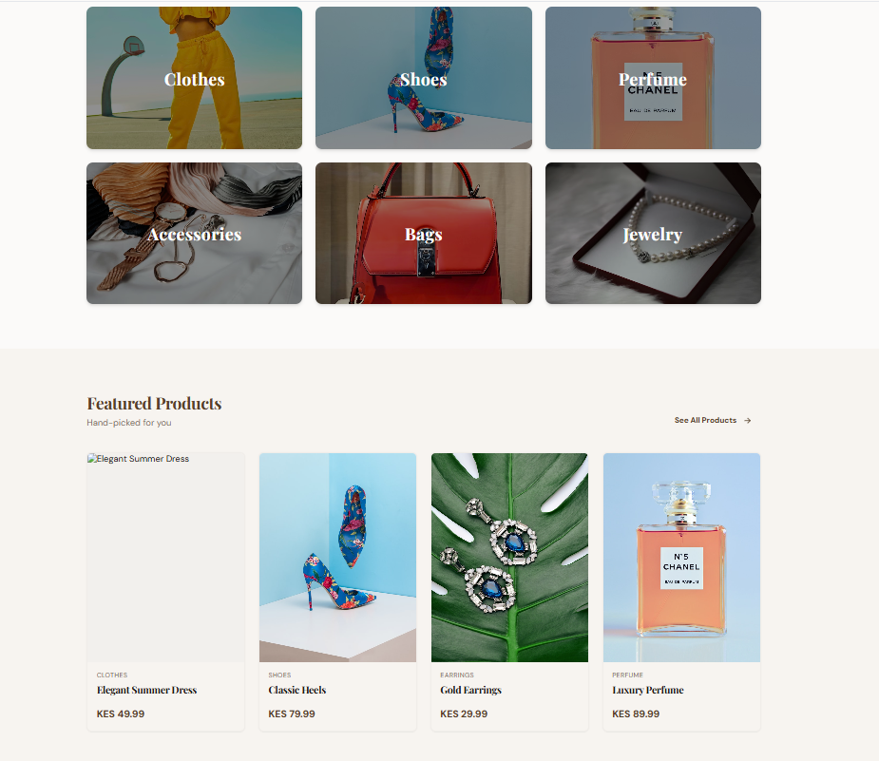
and at las the foot must look like this

the default color to be white and brown only and this website must be responsive in all ways.
1.when the user clicks on shoes or perfumes or clothes or accessories or bags it must go a page of that specific selection only and display that content info only
2.each product must display it’s own content
3.each item must have item information and whatsap link directlying to this number :0722439280
and an Instagram direct link to the communication field of this account https://www.instagram.com/batel_collections/
and this must be applied for all the produc
4. The price tag for each item must contain price in Rwf or usd
5.display the changing image on the dashboard and use the image in directory dashboard_content as the changing images
6.on the footer set the year to change automatically as the year pass on
7.and make this website responsive to used for all devices

